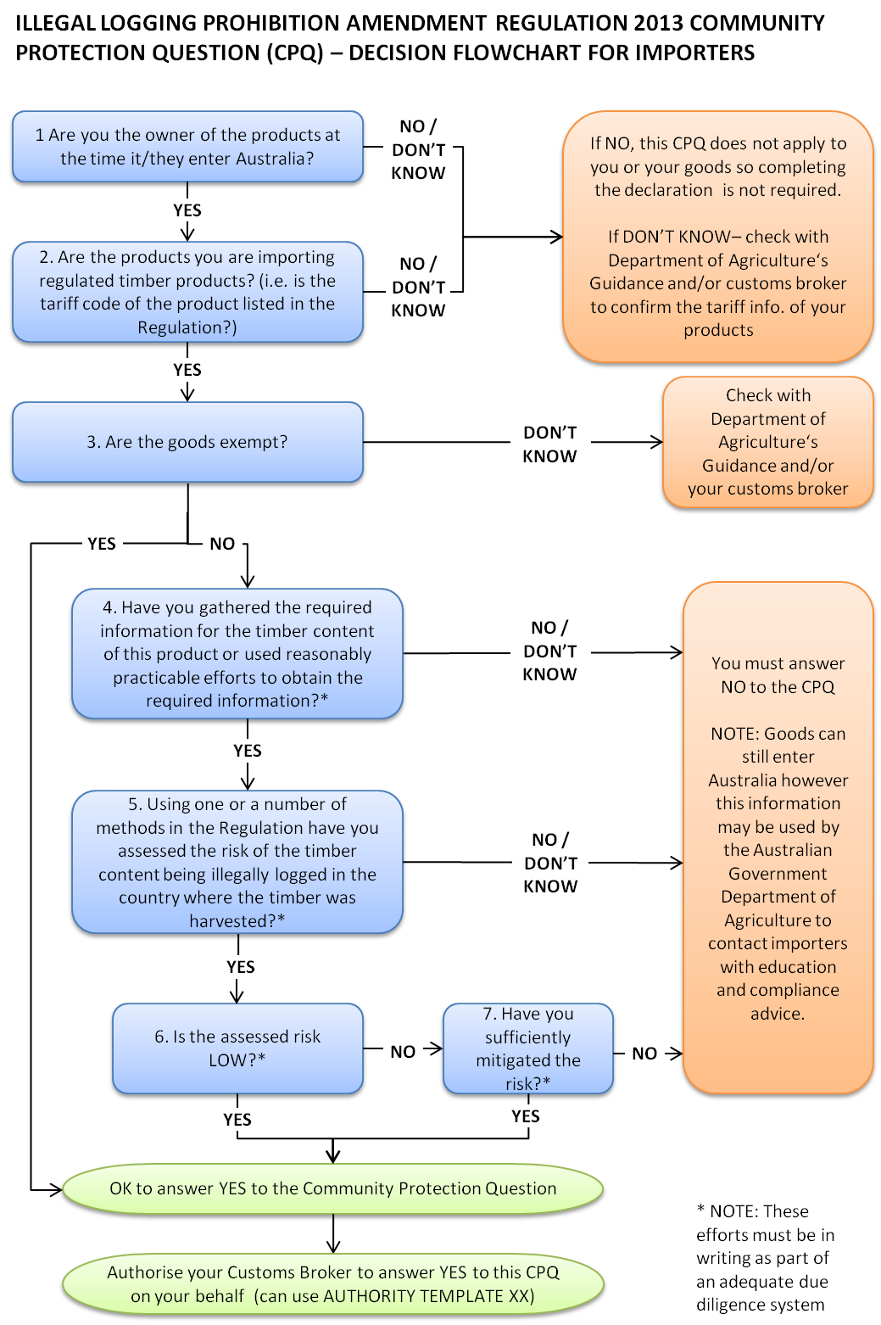

Importer authority for customs broker or other agent to answer Illegal Logging Prohibition CPQ
AUTHORITY TEMPLATE XX – AMEND AS DESIRED / NEEDED
With reference to the Illegal Logging Prohibition Act 2012 and the Illegal Logging Prohibition Regulation Amendment 2013 (Illegal Logging Prohibition legislation)

I / we ……………………………………………………………............................... {insert timber product importer name and ABN or CCID number} hereby authorise TCF International to answer YES to the following Community Protection Question (# 510): HAS THE IMPORTER COMPLIED WITH THE DUE DILIGENCE REQUIREMENTS OF THE ILLEGAL LOGGING PROHIBITION ACT 2012 AND ASSOCIATED REGULATIONS? (IF PRODUCT IS EXEMPT OR DOES NOT CONTAIN TIMBER, ANSWER YES.)
as I/we declare I/we have met the due diligence requirements of the Illegal Logging Prohibition legislation for the regulated timber products that are the subject of this declaration.
The timber products covered are the following: {insert product(s) 4 digit (or greater) tariff code; supplier name and address or attach overleaf as appropriate}
..................................................................................................................................................................

This declaration operates for a period from XX/XX/XXXX or consignment number XXXXXXXXXXXX {delete as appropriate}. Should this information change we will update TCF International accordingly
I / we absolve TCF International ABN 43071011320 from any liability in relation to this declaration.

........……………………………….................. ........……………………………….................. ................................

Name of importer representative Signature of importer representative Date of declaration

For further information contact:

..................................................................................................................................................................

Contact name and telephone number of regulated timber product importing person/company in relation to this declaration.
Products tariff code | Supplier name | Supplier address

Regulated timber product covered by this declaration:

........………………………………..................

Initial of importer representative

